5/12/2026
Themba Ntimane
Junior Software Engineer
API Documentation
LMS Core
Table of Contents
Technical API Endpoint Specifications & Integration Blueprint 2
API wrapper patterns 2
Detailed endpoints matrix 3
Authentication & Session Gateways 3
Organization & Tenant Management 3
Staff & Operations 4

Technical API Endpoint Specifications & Integration Blueprint
System Metadata
Local Testing Workspace: http://localhost:5243/api
Interactive Protocol Panel: /scalar/v1
Raw Protocol Definition Document: /openapi/v1.json
Payload Format: application/json.
Overview:
This Document Outlines An Introduction in how to interact with the system Endpoints.

API wrapper patterns
All transactional endpoints conform strictly to the unified ApiResponse<T> envelope contract. This layout structure guarantees that frontend network handlers can parse error mechanics consistently without breaking layout models.
Successful Json Response Structure:
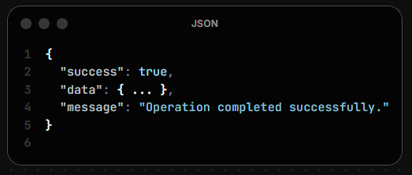
Failed Response Json Structure:
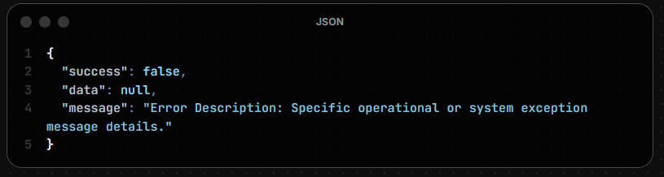

Detailed endpoints matrix
Authentication & Session Gateways
Authenticates corporate personnel profiles
POST /Auth/login
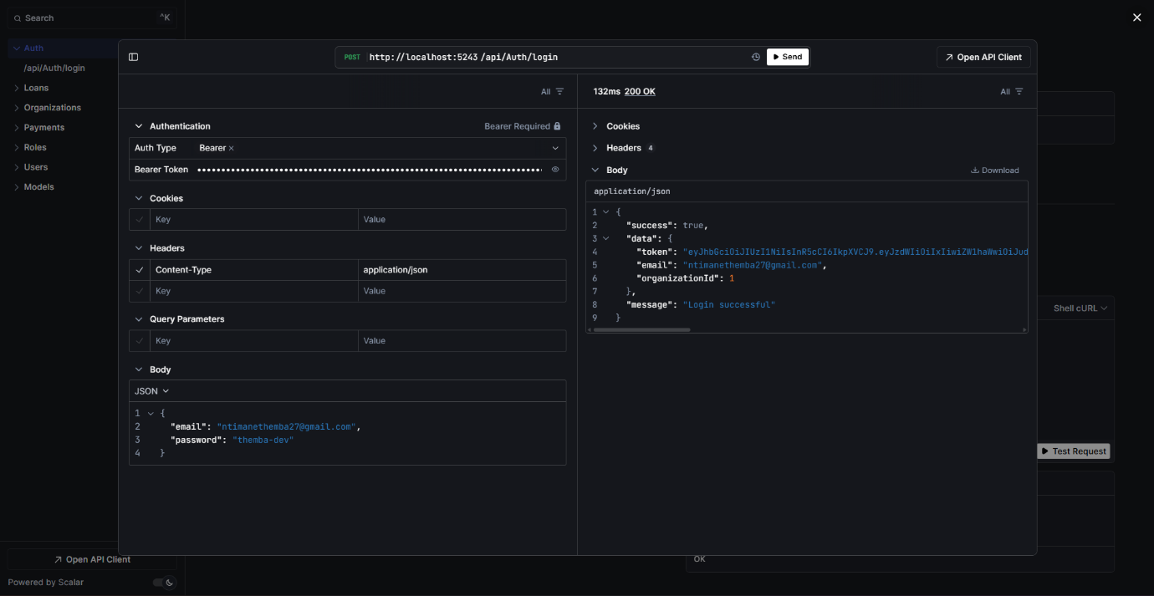

Organization & Tenant Management
GET /Organizations
Extracts a absolute index registry of all onboarded corporate branches inside the platform ecosystem. (Accessed Only By Admins from Main Branch)
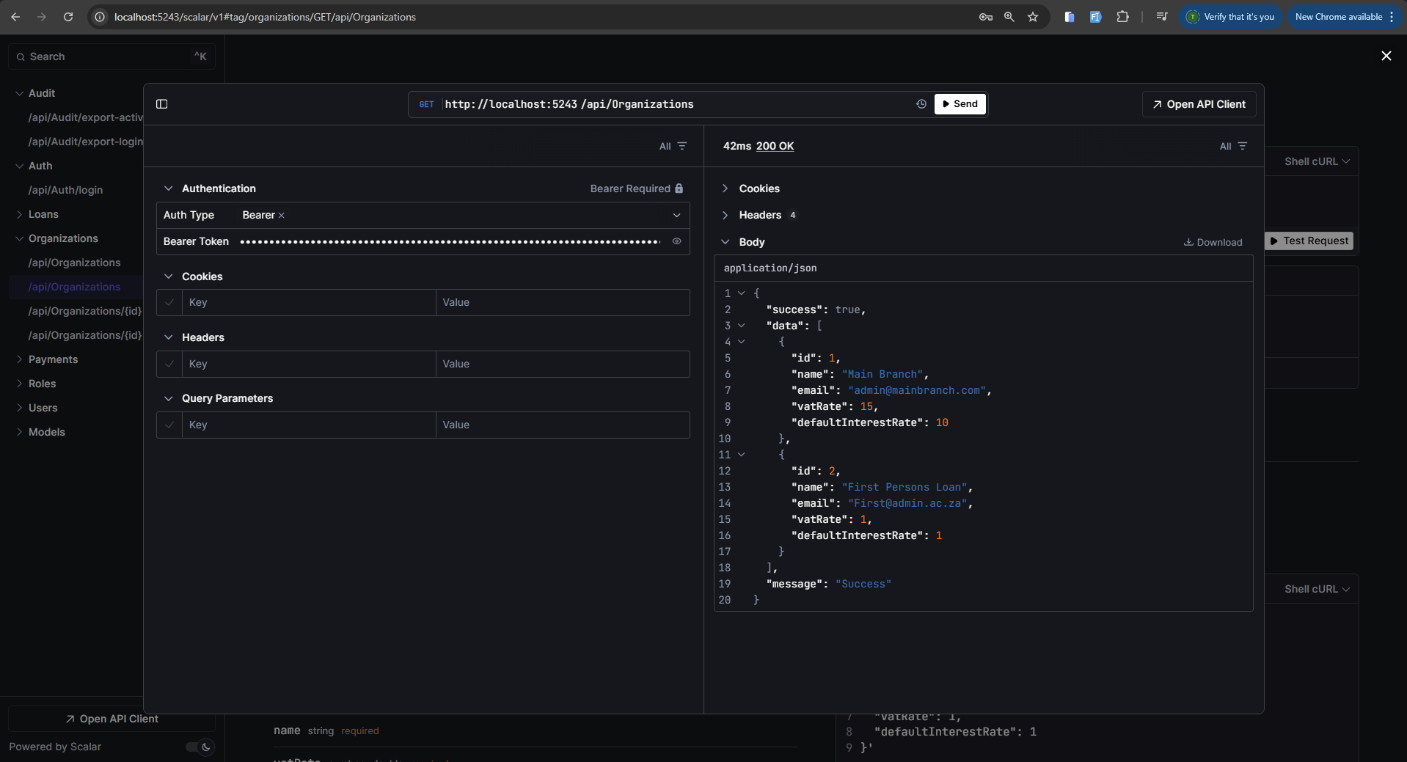

PUT /Organizations/{id}
Updates configuration parameters for an isolated operational tenant organization footprint.
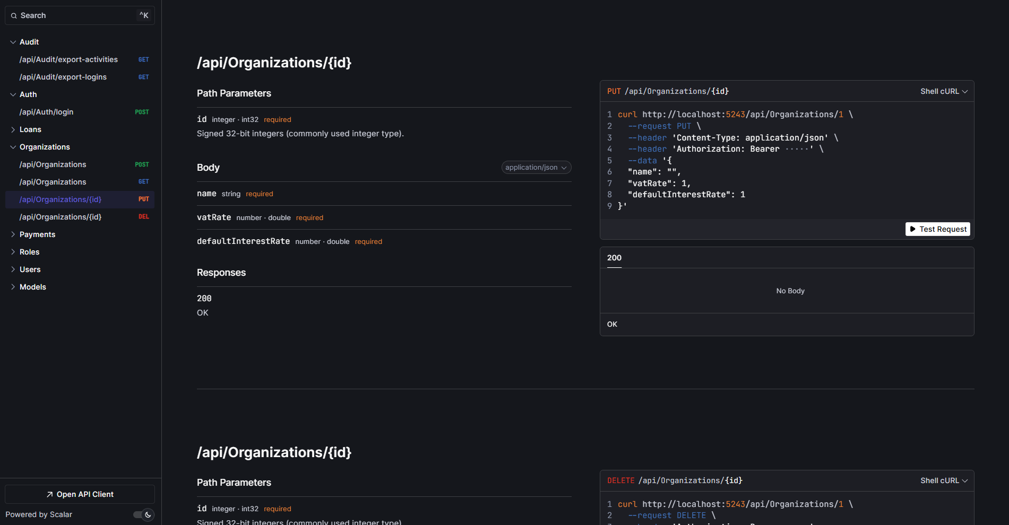
POST/Organizations
Onboarding a new Tenant/ Organization to use the system
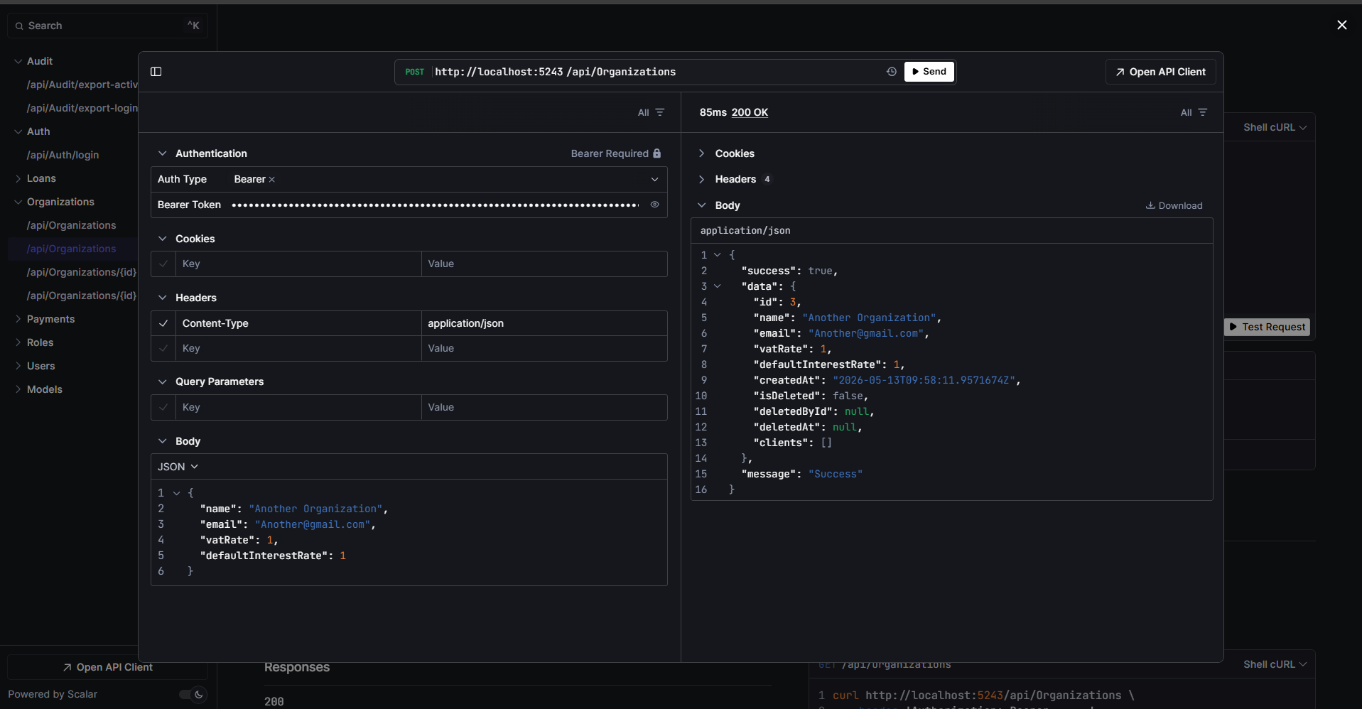
DELETE /Organizations/{id}
Soft Deletetes an Organization
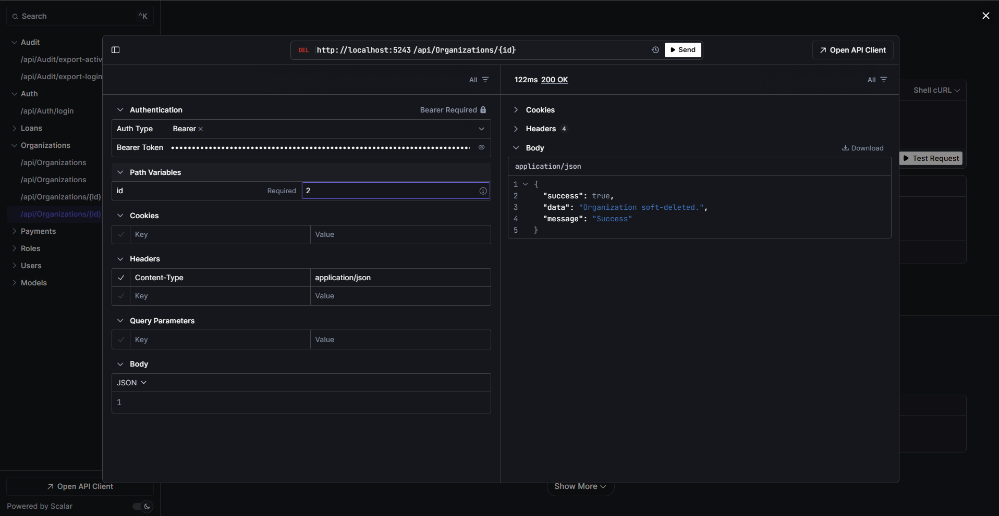

Staff & Operations
Introduces an employee context into the organizational workspace
POST /Users
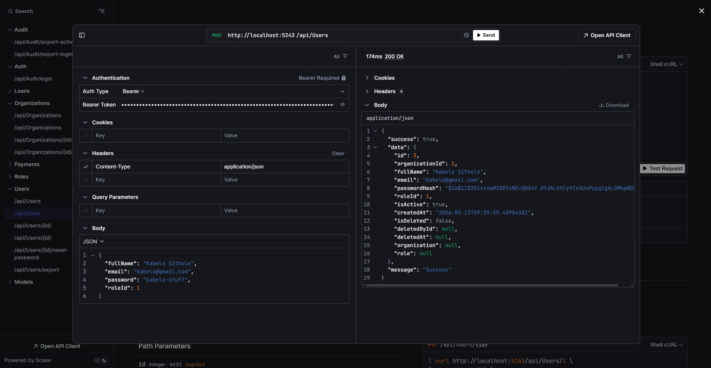

GET /Users/export
Queries the tenant user directory table and compiles the active records straight into a styled OpenXML binary file.
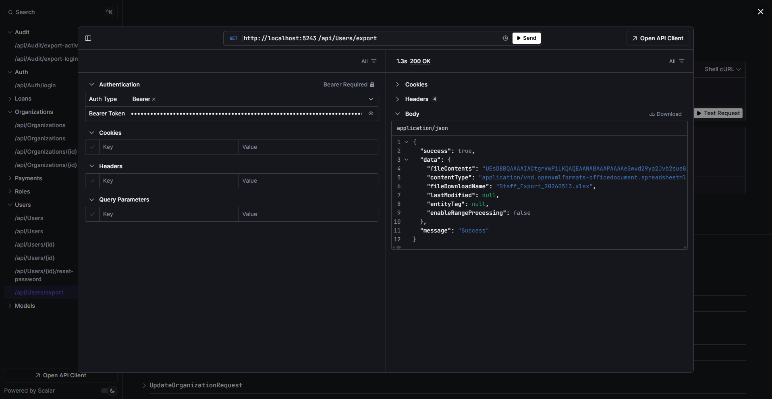

Capital Allocation & Lending Ledger
POST /Loans/auto-issue
Executes an atomic workflow validation sequence: checks if a customer email is unrecognized, creates their profile, snapshots live organization operational rates, and generates an active loan record inside an isolated transaction scope.
